CHINESE FLAGSHIP SECONDARY CURRICULUM
LEVEL 3 - MY EXTENDED WORLD (PART 2)

Unit 4: Travel
Integrated Performance Assessment

Novice Novice Novice Intermediate Intermediate Intermediate
Low ➔ Mid ➔ High ➔ Low ➔ Mid ➔ High ➔

Learning Targets:

- I can read and demonstrate comprehension of several websites about famous sites in Beijing.
- Students can get direction by reading the map or asking another person.
- I can write a blog entry describing the places I visited.
- I can make a presentation to my class about my visit.

Task Overview

You are traveling to Beijing for summer vacation to visit important landmarks and sites. In order to prepare yourself for the trip, you read several websites about the most famous locations and make plans for the trip. You obtain the proper visa, pack your suitcase, purchase the plane ticket and leave for Beijing. Once at the Beijing airport, you cannot locate your luggage. You go to the customer service counter to file a claim. You need to fill out the form and describe the items in your luggage. Luckily, the airport finds your luggage based on the description.

You love to shop and eat traditional Chinese food. You search various websites to find the best restaurants and stores in Beijing. You ask the hotel clerk to give you directions and modes of transportations to get there. Next day, you use the information from your web searches to visit various important landmarks. After the trip, you post blogs to share your experience in Beijing. At school, your Chinese teacher asks you to talk about your trip to the class and answer students’ questions.

Interpretive Reading Task (Reading text plus comprehension questions):

You are traveling to Beijing for the summer vacation. In order to visit the important landmarks and sites, you search websites such as www.qunar.com to find information about Beijing and help you get around. You read the attached website pages and local posters about shopping and dining in Beijing in order to learn as much as you can to enrich your travel.
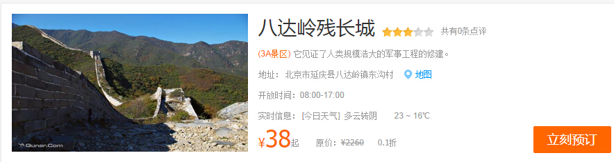
Please answer the following questions.

- Is the above information about shopping?
- Yes (b) No
- You will find this information in:
(a) textbook (b) newspaper (c) website
- How is today’s weather?
- raining (b) cloudy (c)sunny
- What is the advertised price(元）?
- 六十八 (b)八十三 (c)三十八
- The words in the orange box “立刻预订” means：
- save (b) booking now (c) deny

The clerk at your hotel offers you a few brochures of important landmarks, stores and restaurants in Beijing: Read the information below from one of the brochures:

“秀水街”是中国最早的自由市场和最著名的商业品牌，有着近三十年的历史。新“秀水街”市场在2005年3月19日开张。“秀水街”的特点是有很多民族特色的商品，比如：服装、饰品（丝绸、珍珠、瓷器）、茶叶、工艺品。 不但可以逛街， 而且“秀水街”还有不少有名的餐馆包括”全聚德“烤鸭，受到许多游客的欢迎。

Please answer the following questions:

- What is the name of the shopping district?
- What merchandise is it famous in this district? Please list at least 3 items.
- How long is the history of this district?
- The paragraph names a famous restaurant in the district, what is the specialty dish there?

Interpersonal Listening and Speaking Task:

You want to explore local shopping and dining places. At your hotel, you ask a clerk at the front desk about suggestions, directions, and modes of transportation to get there. You may be asked to take a bus, subway or a taxi.

Presentational Writing Task:

Your vacation in Beijing now comes to a close ,and you are on your way back to US. You decide to post a blog about the fun things you did on this trip.You want to share your favorite places to go shopping and dining, your top three unforgettable events and famous attractions in Beijing.

Extension:
When you go to file the lost luggage claim, the customer service representative asks you to fill out the claim form and describe the items in your luggage.

Presentational Speaking Task:

When you return home, your Chinese teacher asks you to talk to the class about your trip and some of the dos and don’ts while traveling in Beijing. You have about 5 minutes to tell the class about your trip.

